How to Use the Proxy Scraper Function
1, Click "Add Source" button to add a task. And choose the search type to "Search", then click Save button to save the settings.
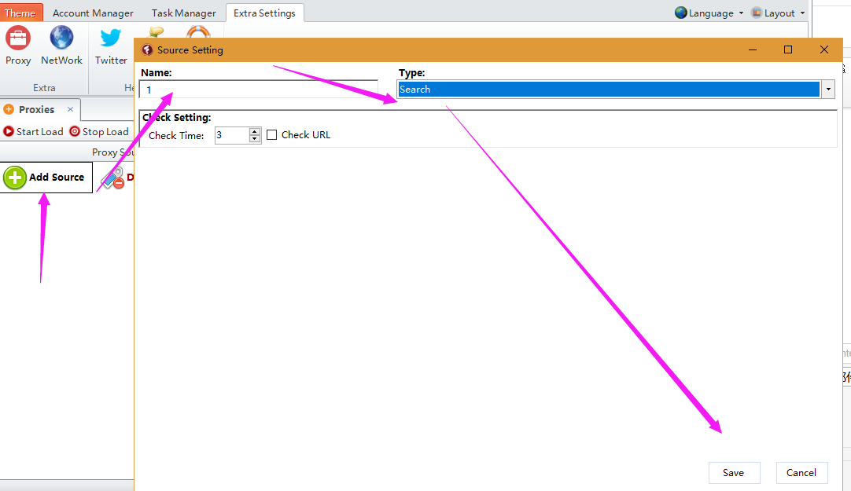

2, Click "Start Load" button to load proxies from the web page. And click "Stop Load" button to stop scraping. And you can view all proxies it scraped out.
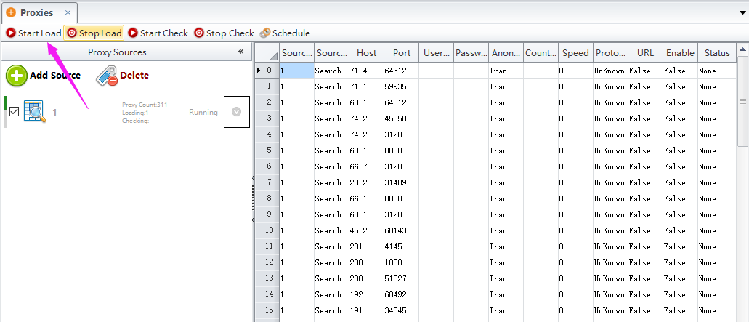

3, Click "Start Check" button to check if the proxy is working. And click "Stop Check" button to stop checking.
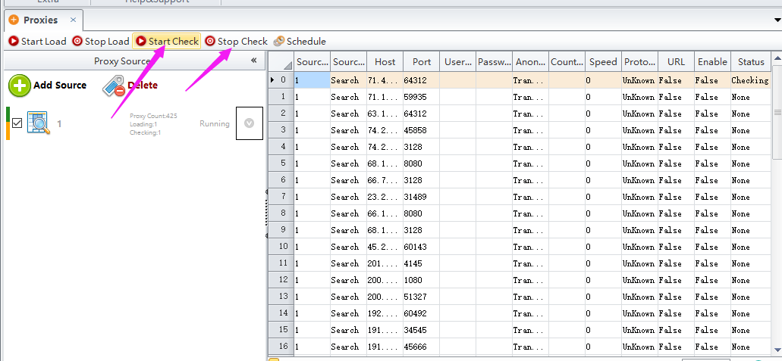

4, Click this button ^ to choose "View Proxies" option to view all scraped proxies in another page. Click Filter button to remove the invalid proxies. Click "Export" button to save the proxies to your local file.
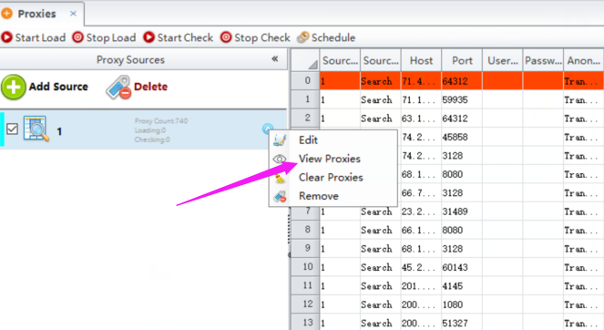
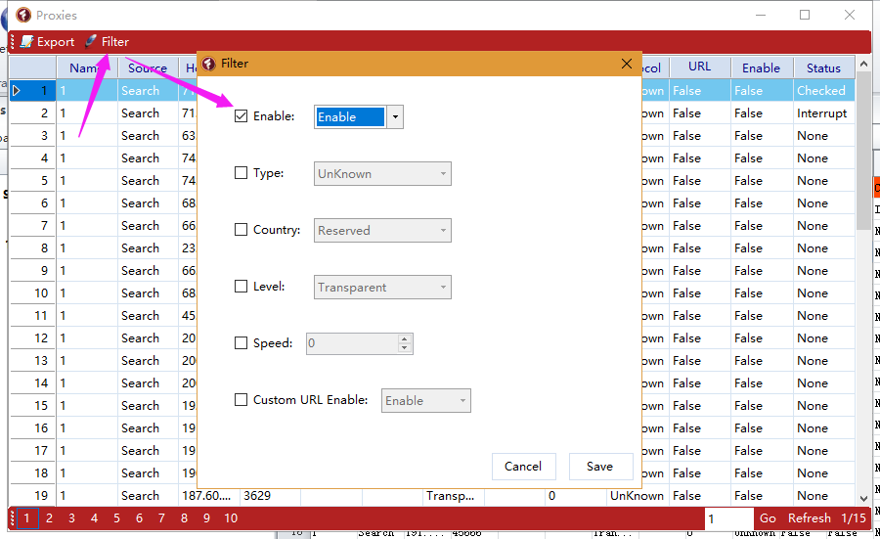
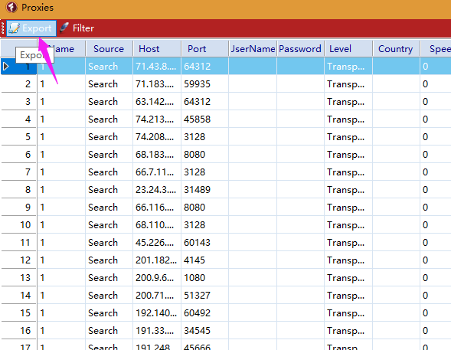
Software will take these scraped proxies in order during running tasks.

